1. Total Sales for each store:

SELECT store_name, SUM(sale_dollars) AS total_sales

FROM bigquery-public-data.iowa_liquor_sales_forecasting.2020_sales_train

GROUP BY store_name;

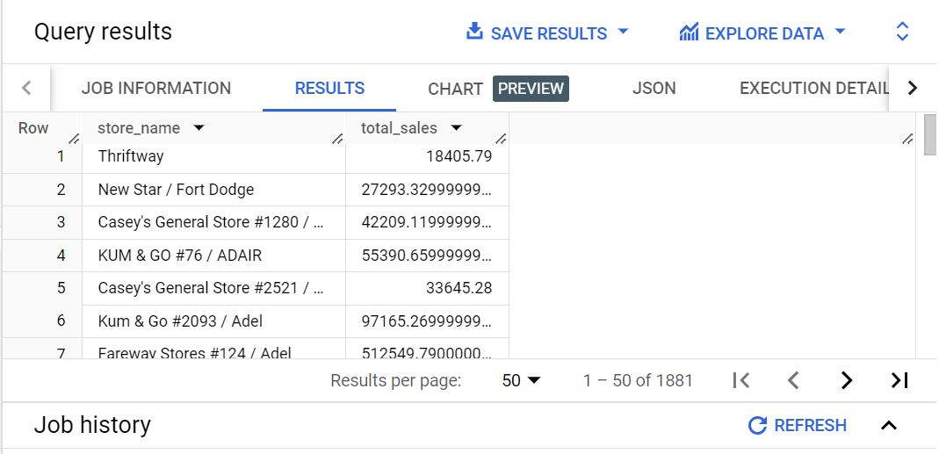

1. Highest sales:

SELECT store_name, SUM(sale_dollars) AS total_sales

FROM bigquery-public-data.iowa_liquor_sales_forecasting.2020_sales_train

GROUP BY store_name

ORDER BY total_sales DESC

LIMIT 1;

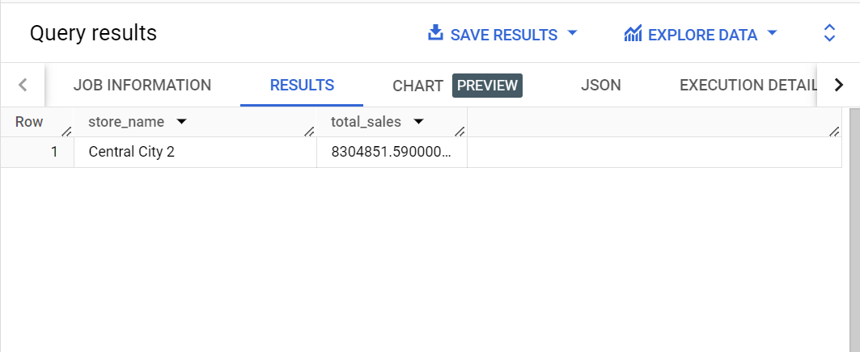

1. Retrieve the records where the sale (in dollars ) is greater than 200,000

SELECT *

FROM bigquery-public-data.iowa_liquor_sales_forecasting.2020_sales_train

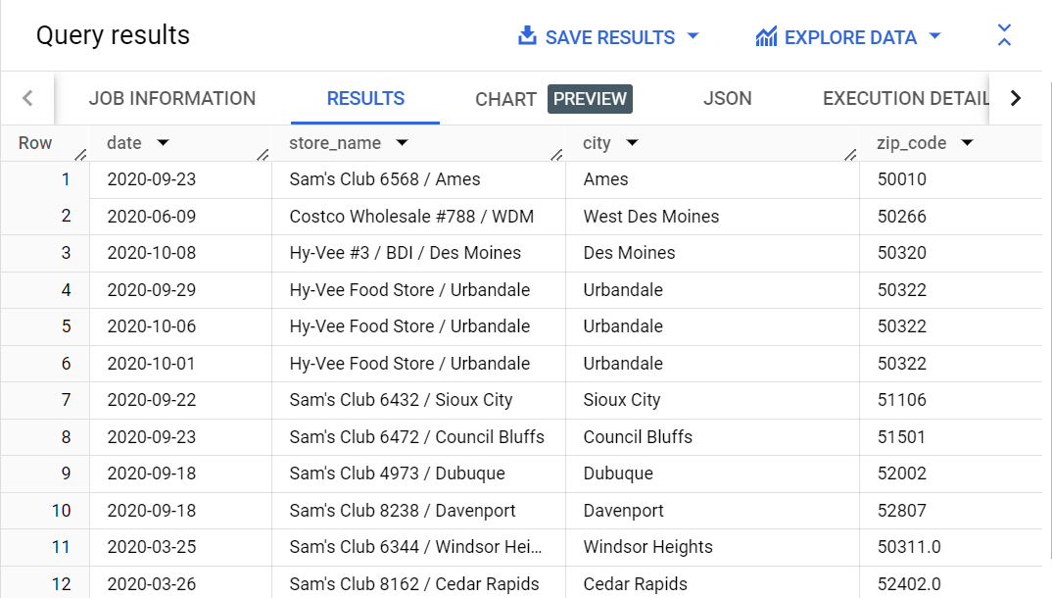WHERE sale_dollars > 200000;

1. Average Sale Amount per transaction:

SELECT AVG(sale_dollars) AS average_sale

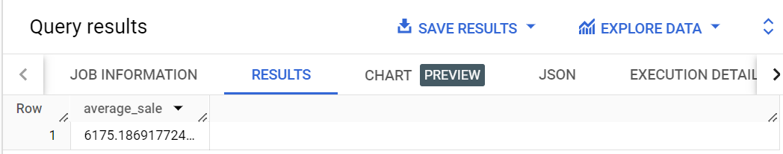FROM bigquery-public-data.iowa_liquor_sales_forecasting.2020_sales_train;

1. Sales between 40,900 to 41,000

SELECT *

FROM bigquery-public-data.iowa_liquor_sales_forecasting.2020_sales_train

WHERE sale_dollars BETWEEN 40900 AND 41000;

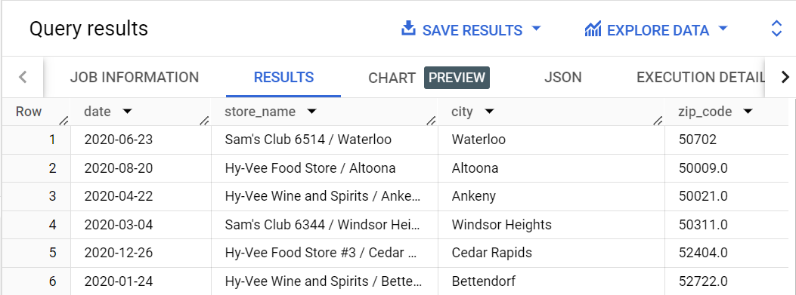

1. Top 3 stores with the highest average sales:

SELECT store_name, AVG(sale_dollars) AS average_sale

FROM bigquery-public-data.iowa_liquor_sales_forecasting.2020_sales_train

GROUP BY store_name

ORDER BY average_sale DESC

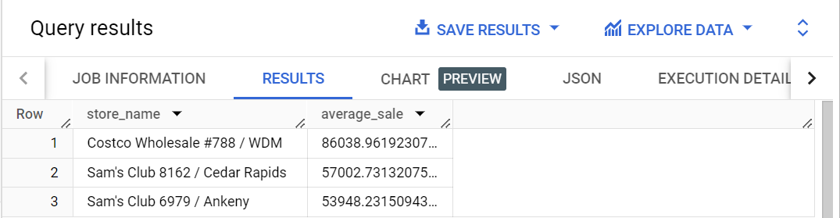LIMIT 3;

1. Total sales for each month:

SELECT EXTRACT(MONTH FROM date) AS month, SUM(sale_dollars) AS total_sales

FROM bigquery-public-data.iowa_liquor_sales_forecasting.2020_sales_train

GROUP BY month

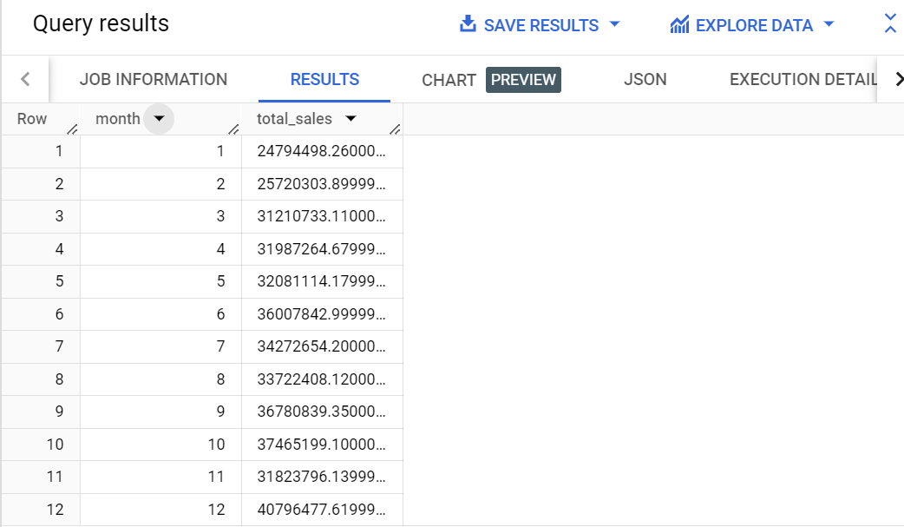ORDER BY month;

1. Find the store with sale of $1002:

SELECT *

FROM bigquery-public-data.iowa_liquor_sales_forecasting.2020_sales_train

WHERE sale_dollars = 1002;

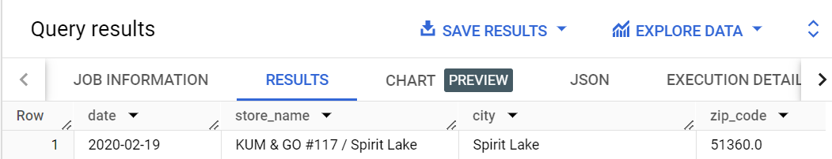

1. Inner Join

SELECT *

FROM bigquery-public-data.iowa_liquor_sales_forecasting.2020_sales_train AS a

INNER JOIN bigquery-public-data.iowa_liquor_sales_forecasting.2021_sales_predict AS b

ON a.store_name = b.store_name;

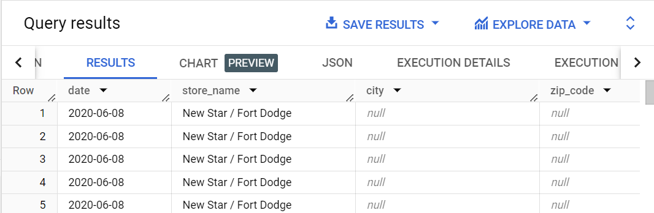LIMIT 5;

1. Left Join:

SELECT *

FROM bigquery-public-data.iowa_liquor_sales_forecasting.2020_sales_train AS a

LEFT JOIN bigquery-public-data.iowa_liquor_sales_forecasting.2021_sales_predict AS b

ON a.county = b.county

WHERE a.county = 'Dallas';

LIMIT 4;

